# Задание #1

Самостоятельно придумать требования для формы регистрации на сайте продажи автозапчастей. Какие поля должны быть и какие между ними могут быть зависимости? Распишите так, чтобы специалист по тестированию мог составить тест-кейсы по этим требованиям.

### **Основные критерии:**

требования должны быть расписаны по пунктам с нумерацией и соответствовать свойствам качественных требований.

Требования:

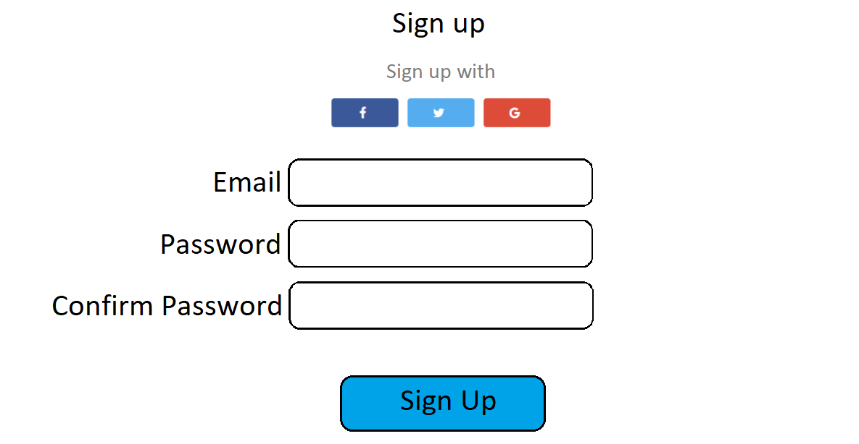

Форма регистрации содержит 3 поля:

1. Field “Email”:
   * Text box
   * Character limit = 320
     + Validation: once user clicks outside of “Email” textbox, validate email character count <= 320
     + If fails validation, then display red border around text box and display message “Email cannot be more than 320 characters long.”
   * Email must be unique within website
     + Validation: once user clicks outside of “Email” textbox, validate email has never been used on the site
     + If fails validation, then display red border around text box and display message “This email address is already in use in another account.”
   * The field must pass a format validity check;
     + Validation: once user clicks outside of “Email” textbox, validate email
       - The email has the form "username@hostname";
       - A username may contain
         1. Latin characters
         2. Numbers
         3. Symbols: ! # $ % & ' * + - / =? ^ _ ` { | } ~
         4. Point, except for the first and last character, which cannot be repeated

* The hostname consists of

1. Several components, separated by a dot and not exceeding 63 characters, and suffixes (first-level domains).
2. Components consist of Latin letters, numbers and hyphens. Hyphens cannot be at the beginning or at the end of a component. Suffixes are a limited list of first-level domains.

* If fails validation, then display red border around text box and display message “Incorrect email format”.
  + Field “Email” can’t be left empty;
    - Validation: once user clicks outside of “Email” textbox, validate field is not empty;
    - If fails validation, then display red border around text box and display message “This field must be filled in”

1. Field “Password”:
   * Text box;
   * 8 <= Character count <= 20;
     + Validation: once user clicks outside of “Password” textbox, validate password 8 <= character count <= 20;

* If fails validation, then display red border around text box and display message “The password cannot be shorter than 8 characters and longer than 20 characters.”.
* Password must contain at least one digit, at least 1 uppercase and at least 1 lowercase characters;
  + - Validation: once user clicks outside of “Password” textbox, validate the presence of digits, lowercase and uppercase characters.
    - If fails validation, then display red border around text box and display message “The password must contain digits, uppercase and lowercase characters”.
* The field “Password” should hide the entered characters;
* Field should allow user to see entered characters after click on Eye icon toggle and hide after second click.





* + Field “Password” can’t be left empty;
    - Validation: once user clicks outside of “Password” textbox, validate field is not empty;
    - If fails validation, then display red border around text box and display message “This field must be filled in”

1. Field “Confirm Password”:
   * Text box
   * 8 <= Character count <= 20;
   * The content of the field must be identical to the content of the password field
     + Validation: once user clicks outside of “Confirm Password” textbox, validate the field is identical to the password field.
     + If fails validation, then display red border around text box and display message “Password didn’t match.”
   * Field should allow user to see entered characters after click on Eye icon toggle and hide after second click. 
   * Field “Confirm Password” can’t be left empty;
     + Validation: once user clicks outside of “Confirm Password” textbox, validate field is not empty;
     + If fails validation, then display red border around text box and display message “This field must be filled in”
2. Also, the user has the ability to sign up using the following social networks: Facebook, Twitter or Google.
   * Button “Facebook”
   * Button “Twitter”
   * Button “Google”
   * After click on one of the buttons, it takes user to integration page of the corresponding social network;
   * After successful registration the form display a message about successful registration of the user and takes user to the main page.
3. Button “Sign up”:
   * Button “Sign up” is greyed out and not clickable unless:
     + Field “Email” passed validation;
     + Field “Password” passed validation;
     + Field “Confirm Password” passed validation;

* Once clicked, the button sends data to the server to create a user account.
  + Message about successful registration: After successful registration the form display a message about successful registration of the user and takes user to the main page.
  + Message about unsuccessful registration: If registration fails, the user should receive an informative error message that explains the reason for the failure and indicates how to correct the problem.

1. All display messages that appear when validation fails are located under the field in which validation failed

# Задание #2

1. Зайти на [сайт](https://qa-ep-bva-practice-assignment.vercel.app/) и прочитать описание (при необходимости воспользоваться переводчиком <https://translate.google.com/?hl=ru> или <https://www.deepl.com/en/translator>)
2. Составить список значений для проверки описанных условий используя техники тест-дизайна. Оформить в виде таблицы в один столбец, можно не ограничиваться 12ю значениями.

### **Основные критерии:**

Минимум 12 значений и напротив указана техника тест-дизайна использованная для каждого значения.

|  |  |  |
| --- | --- | --- |
|  | **Values** | **Test design technique** |
| 1. | -10001 | Boundary Value Analysis |
| 2. | -10000 | Boundary Value Analysis |
| 3. | -9999 | Boundary Value Analysis |
| 4. | -1 | Boundary Value Analysis |
| 5. | 0 | Boundary Value Analysis |
| 6. | 1 | Boundary Value Analysis |
| 7. | 9999 | Boundary Value Analysis |
| 8. | 10000 | Boundary Value Analysis |
| 9. | 10001 | Boundary Value Analysis |
| 10. | -11111 | Equivalence Partitioning |
| 11. | -8999 | Equivalence Partitioning |
| 12. | 0 | Equivalence Partitioning |
| 13. | 4000 | Equivalence Partitioning |
| 14. | 11123 | Equivalence Partitioning |
| 15. | 5.666 | Equivalence Partitioning |
| 16. | #$%(@*&$ | Equivalence Partitioning |
| 17. | abc | Equivalence Partitioning |